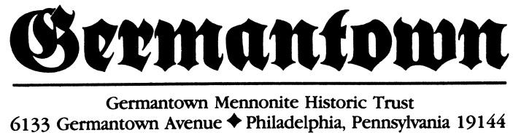

Directions & Parking

Our street address is 6121 Germantown Avenue, Philadelphia PA 19144. Our office phone is (215) 843-0943.
We are located on the east side of Germantown Avenue between Herman and Pastorius Streets (just west of Walnut Lane), across from the Germantown branch of the Settlement Music School. Metered street parking is available directly in front of the Meetinghouse along both sides of Germantown Avenue. The 2-hour meters are in effect 8 am - 6pm Monday through Saturday, and are strictly enforced. Change (50 cents/hour) or a Smartcard is required (Unlike many Philadelphia locations, there are no kiosks that accept credit/debit cards).
Fastest Route for Cars & Vans – via Interstate 76
*Please note: Buses are not permitted on Lincoln Drive. (See alternate bus directions below.)
- From Interstate 76 (Schuylkill Expressway) take exit 340-A (Kelly Drive/Lincoln Drive Exit) following signs to Lincoln Drive (Be advised that from I-76 East, this is a left exit)
- Follow Lincoln Drive for approximately 1 1⁄2 miles passing through two traffic signals.
- Immediately after the second traffic signal, turn right on Harvey Street
- Continue on Harvey to the third traffic signal.
- Turn left onto Germantown Avenue.
- Follow Germantown Avenue for three blocks to 6121 Germantown Avenue.
- The Historic Mennonite Meetinghouse is on the right between Herman and Pastorius Streets.

Alternate Route for Bus Traffic - via Interstate 76
- From Interstate 76 (Schuylkill Expressway) take exit 340-A (Kelly Drive/Lincoln Drive Exit) following signs to Ridge Avenue west (Be advised that from I-76 East, this is a left exit)
- Continue on Ridge Avenue following signs through a five point intersection.
- Turn right onto Walnut Lane.
- Continue on Walnut Lane for approximately 2 miles following signs for
- Walnut Lane at the Blue Bell Hill Circle.
- Turn left onto Germantown Avenue for 1 1⁄2 blocks to 6121 Germantown Avenue.
- The Historic Mennonite Meetinghouse is on the right between Herman and Pastorius Streets.

Alternate/Scenic Route for Buses, Cars or Vans - through Chestnut Hill & Mt. Airy via Germantown Ave

From PA Turnpike
- Take exit 333 (Norristown) following signs for Germantown Pike east toward Philadelphia. (Germantown Pike becomes Germantown Avenue upon entering Philadelphia.)
- Continue on Germantown Pike/Avenue for approximately 8 miles passing through Chestnut Hill and Mount Airy neighborhoods of Philadelphia to 6121 Germantown Avenue.
- The Historic Mennonite Meetinghouse is on the left between Pastorius and Herman Streets.

From Route 309 South
- Take the Mount Airy exit and Easton Road. (Easton Road becomes Mt. Airy Avenue)
- Follow Easton Rd/Mt Airy Ave for approximately 2 miles
- Turn left onto Germantown Avenue
- Continue on Germantown Avenue for approximately 1 1⁄2 miles to 6121 Germantown Avenue.
- The Historic Mennonite Meetinghouse is on the right between Herman and Pastorius Streets.

